THE UNIVERSITY OF AZAD JAMMU & KASHMIR
DEPARTMENT OF SOFTWARE ENGINEERING

Student Name | Raja Wajihullah Khan | 
Roll Number | 2024-SE-28
Course Name | Digital Image Processing Lab
Course Code | SE-3104
Session | 2024-2028 (BS SE - 5th Sem)
Department Name | Department of Software Engineering
Task / Assignment No. | Lab Task #01 Report
Instructor Name | Engr. Fahad Nisar
Submission Date | October 23, 2026
Topic / Title | Python Setup, Fundamentals, & Imports

Step 1 & Step 2: Python Installation & Version Verification
Command executed in Command Prompt to verify Python and pip installation:
python --version
python -m pip --version

Output Verification:
Python 3.11.5
pip 23.2.1 from C:\Python311\lib\site-packages\pip (python 3.11)

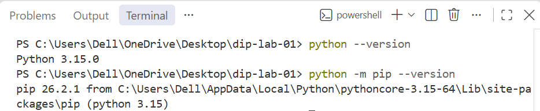

Step 3: VS Code Setup & Python Interpreter Selection
Installed VS Code, added the Python extension by Microsoft, and selected the active Python 3 interpreter using Ctrl + Shift + P -> 'Python: Select Interpreter'.

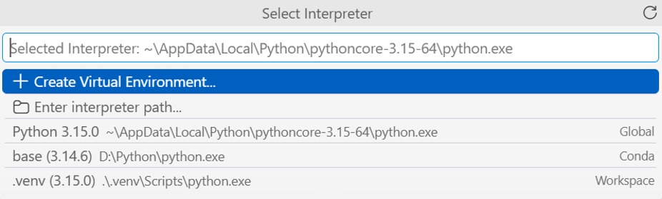

Step 4: First Python Program (hello.py)
Source Code for hello.py:
# My first Python program
print('Hello, Digital Image Processing!')

Execution Command & Output:
C:\dip-lab-01> python hello.py
Hello, Digital Image Processing!
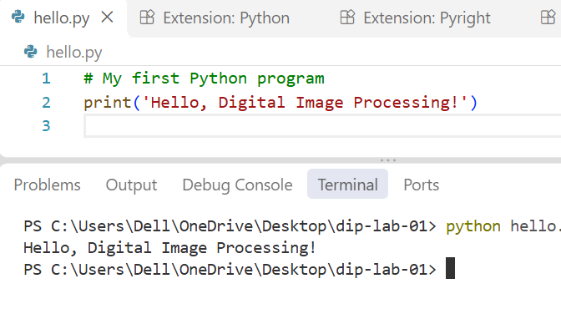

Step 5: Basic Python Exercises (basics.py)
Complete source code for basics.py solving Exercises 1 to 6:
# =========================================================
# Exercise 1: Variables and Data Types
# =========================================================
width = 640
height = 480
image_name = "sample.png"
is_color = True
print(f"width: {width}, type: {type(width)}")
print(f"height: {height}, type: {type(height)}")
print(f"image_name: {image_name}, type: {type(image_name)}")
print(f"is_color: {is_color}, type: {type(is_color)}")
total_pixels = width * height
print("Total number of pixels:", total_pixels)
print("-" * 50)
# =========================================================
# Exercise 2: if, elif, and else
# =========================================================
test_values = [-1, 0, 127, 128, 255, 256]
for intensity in test_values:
if intensity < 0 or intensity > 255:
label = "Invalid"
elif intensity >= 128:
label = "Bright pixel"
else:
label = "Dark pixel"
print(f"Intensity {intensity}: {label}")
print("-" * 50)
# =========================================================
# Exercise 3: for and while Loops
# =========================================================
# for loop
pixel_values = [20, 130, 255]
print("For loop classification:")
for pixel in pixel_values:
if pixel >= 128:
print(f"Pixel {pixel}: Bright pixel")
else:
print(f"Pixel {pixel}: Dark pixel")
# while loop
print("
While loop output:")
counter = 0
while counter < 3:
print(counter)
counter += 1
print("-" * 50)
# =========================================================
# Exercise 4: Functions
# =========================================================
def is_bright(pixel, threshold=128):
return pixel >= threshold
print("is_bright(127):", is_bright(127))
print("is_bright(128):", is_bright(128))
print("is_bright(200, 210):", is_bright(200, 210))
print("-" * 50)
# =========================================================
# Exercise 5: Lists and Tuples
# =========================================================
pixels = [0, 128, 255]
print("First item:", pixels[0])
pixels[1] = 150
pixels.append(64)
print("Updated list:", pixels)
print("List length:", len(pixels))
size = (640, 480)
w, h = size
print(f"Unpacked tuple -> Width: {w}, Height: {h}")
# Mutability Explanation:
# A list item can be changed because lists are mutable data structures in Python,
# allowing in-place modification of elements. On the other hand, a tuple item cannot
# be changed because tuples are immutable, meaning their structure and contents
# are fixed upon creation to guarantee data integrity.
print("-" * 50)
# =========================================================
# Exercise 6: Dictionaries and Sets
# =========================================================
image = {"width": 640, "height": 480}
image["mode"] = "RGB"
print("Width from dict:", image["width"])
print("Mode from dict:", image["mode"])
animal_list = ["cat", "dog", "cat", "bird"]
unique_animals = set(animal_list)
print("Unique animal count:", len(unique_animals))
Execution & Output of basics.py
python basics.py
Expected Terminal Output:
width: 640, type: <class 'int'>
height: 480, type: <class 'int'>
image_name: sample.png, type: <class 'str'>
is_color: True, type: <class 'bool'>
Total number of pixels: 307200
--------------------------------------------------
Intensity -1: Invalid
Intensity 0: Dark pixel
Intensity 127: Dark pixel
Intensity 128: Bright pixel
Intensity 255: Bright pixel
Intensity 256: Invalid
--------------------------------------------------
For loop classification:
Pixel 20: Dark pixel
Pixel 130: Bright pixel
Pixel 255: Bright pixel
While loop output:
0
1
2
--------------------------------------------------
is_bright(127): False
is_bright(128): True
is_bright(200, 210): False
--------------------------------------------------
First item: 0
Updated list: [0, 150, 255, 64]
List length: 4
Unpacked tuple -> Width: 640, Height: 480
--------------------------------------------------
Width from dict: 640
Mode from dict: RGB
Unique animal count: 3
Execution Output of basics.py:
--- Exercise 1: Variables and Data Types ---
width: 640 | Type: <class 'int'>
height: 480 | Type: <class 'int'>
image_name: sample.png | Type: <class 'str'>
is_color: True | Type: <class 'bool'>
Total Pixels: 307200
--- Exercise 2: if, elif, and else ---
Pixel Value: -1 -> Label: Invalid
Pixel Value: 0 -> Label: Dark pixel
Pixel Value: 127 -> Label: Dark pixel
Pixel Value: 128 -> Label: Bright pixel
Pixel Value: 255 -> Label: Bright pixel
Pixel Value: 256 -> Label: Invalid
--- Exercise 3: for and while Loops ---
For Loop Results:
Value: 20 -> Dark pixel
Value: 130 -> Bright pixel
Value: 255 -> Bright pixel
While Loop Results:
Counter: 0
Counter: 1
Counter: 2
--- Exercise 4: Functions ---
is_bright(127) -> False
is_bright(128) -> True
is_bright(200, 210) -> False
--- Exercise 5: Lists and Tuples ---
Original list: [0, 128, 255]
First item: 0
Updated list: [0, 150, 255, 64]
Length of list: 4
Unpacked Tuple -> Width: 640, Height: 480
--- Exercise 6: Dictionaries and Sets ---
Dictionary Width: 640
Dictionary Mode: RGB
Unique labels set: {'cat', 'dog', 'bird'}
Number of unique labels: 3

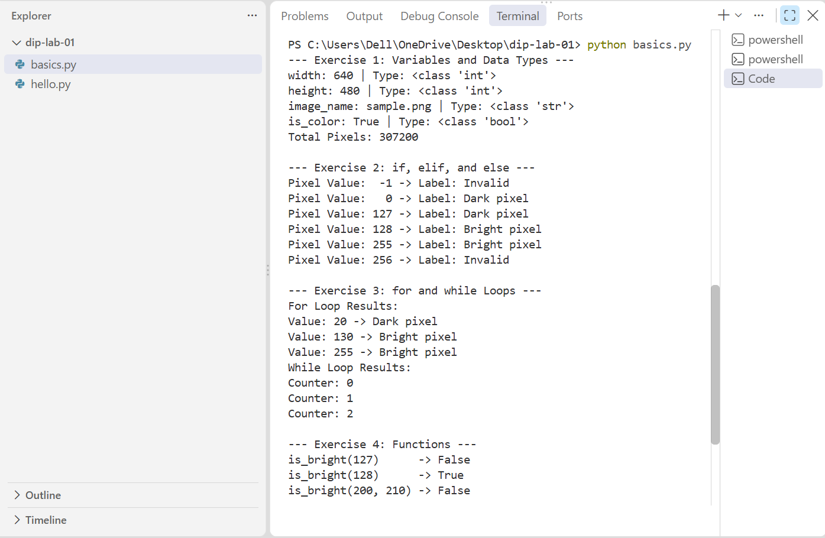

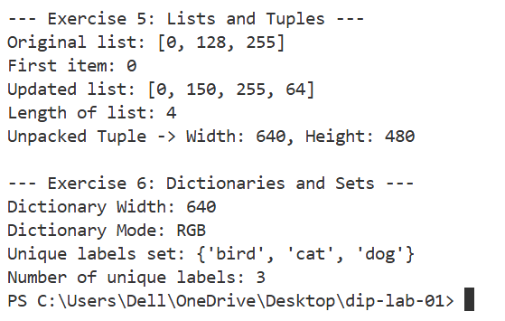

Step 6 & Step 8: Package Installation & Import Verification
Step 6: Installing Packages
Command executed to install numpy, pillow, and matplotlib:
python -m pip install numpy pillow matplotlib
Command executed to verify installed package details:
python -m pip show numpy pillow matplotlib

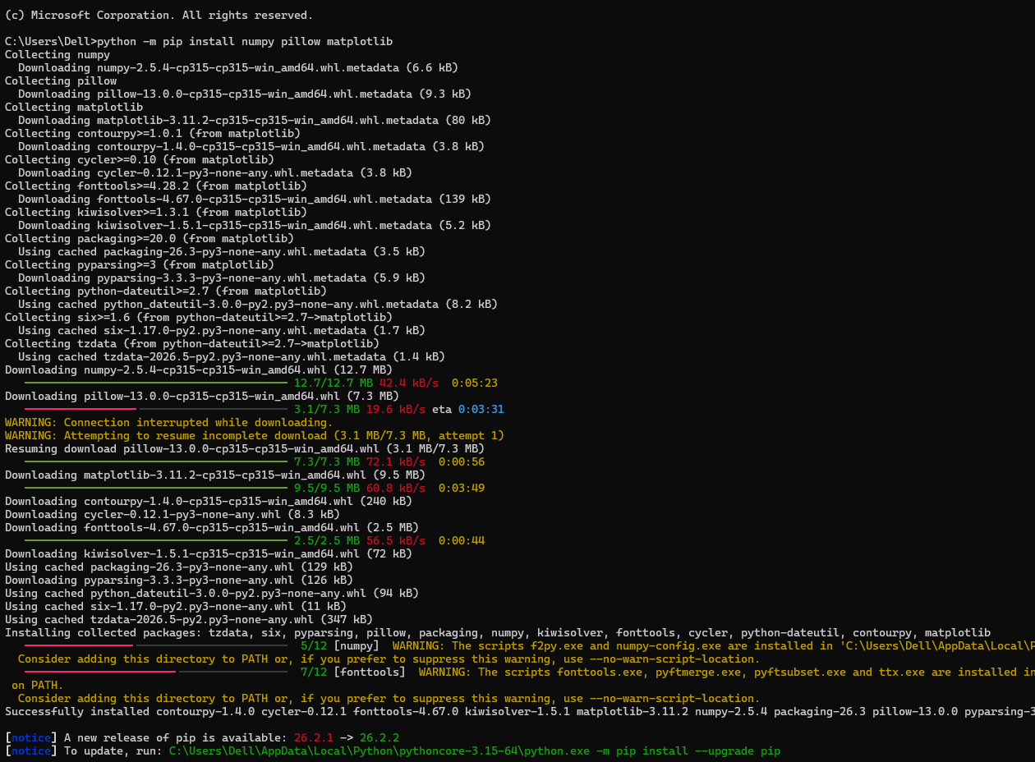

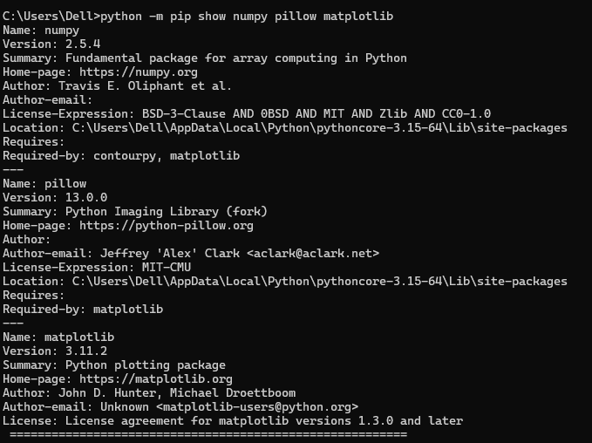

Step 8: Write and Verify Import Statements (lab01_imports.py)
Source Code for lab01_imports.py:
import numpy as np
from PIL import Image
import matplotlib.pyplot as plt
Command executed:
python lab01_imports.py
Output: Execution completes silently without error, returning directly to command prompt (verifying all packages are correctly installed).

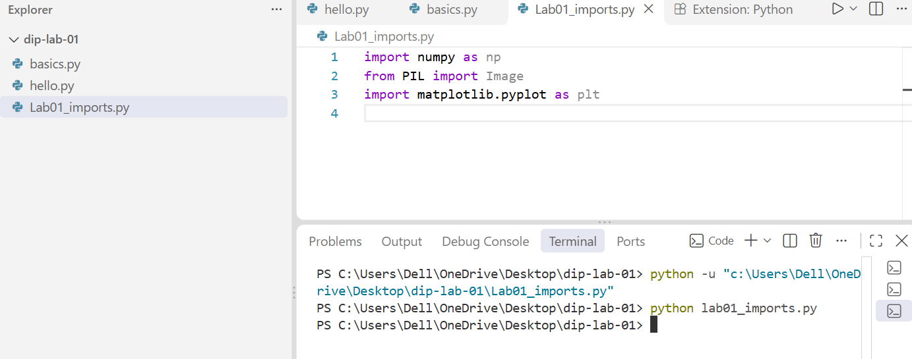

Conceptual Questions & Explanation
- Python vs. Pip:
Python is the core programming language runtime/interpreter that executes Python scripts and code. On the other hand, pip (Package Installer for Python) is a package management system used to download, install, update, and manage additional third-party libraries and dependencies (such as NumPy, Pillow, and Matplotlib) from the Python Package Index (PyPI).
2. Purpose of Import Statements:
Import statements are used to load external modules and libraries into the current Python script's scope. In Digital Image Processing, imports allow access to pre-built functions and mathematical tools—such as NumPy for fast multidimensional array processing, Pillow for image reading and editing, and Matplotlib for plotting and visual display—without writing them from scratch.

6. Lab Assessment Criteria Summary
Criterion | Required Evidence Included | Max Marks
Installation and setup | Python/pip checks, VS Code interpreter selection, project folder, hello.py output. | 2
Variables and conditions | Exercises 1–2: exact variable types, 307200 pixel count, and all 6 boundary test labels. | 2
Loops and functions | Exercises 3–4: for/while loops output and is_bright() function with default/custom thresholds. | 2
Collections | Exercises 5–6: List manipulation, tuple unpacking, dictionary lookup, set uniqueness, and mutability explanation. | 3
Packages and imports | NumPy, Pillow, Matplotlib installation via pip, show command, and error-free lab01_imports.py run. | 2
Report and understanding | Complete student details, structured sections, clear simple English explanation, and Python vs pip definition. | 1

